General Chemistry I (Casanova)
Assignment 3: Chapters 3 & 4
Name: _____________________________________________ M/W or T/R ?
1. Define the following terms:
a) Polar molecule –

b) Solvation –

c) Electrolyte –

d) Nonelectrolyte –

e) Spectator ion –

f) Precipitate –

g) Acid –

h) Base –

i) Salt –

j) Redox –

k) Oxidation –

l) Reduction –

m) Oxidizing agent –

n) Reducing agent –

Setup of each problem must be shown when performing ANY CALCULATION from this point on. Attention should be given to significant figures.

2. Given the following figure, explain the polar nature of water.
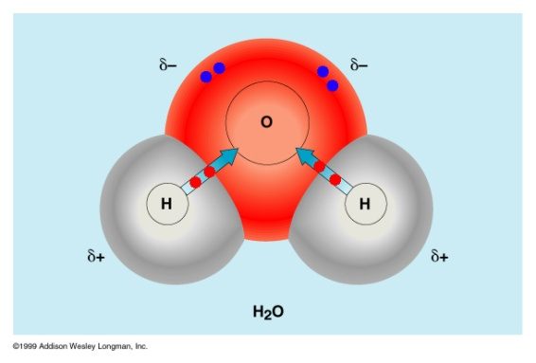

3. Given the following figure explain the process of a salt being solvated in water.
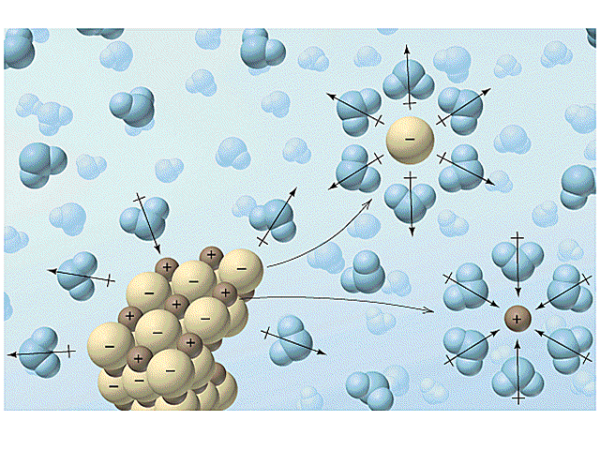

4. Before attempting this question you are strongly encouraged to read through PRACTICE EXERCISE FOR IONIC EQUATIONS found on the RESOURCE page in CANVAS!
For each of the reactions below:
- Translate from words to the appropriate chemical formulas indicating the states for each substance.
- Balance the chemical equation with the appropriate coefficients.
- Write the molecular equation, ionic equation and the net ionic equation for each. Be sure to show all charges as well as states.
- In the ionic equation circle all spectator ions.
- If both products are aqueous salts the reaction will not proceed. For reactions like this, simply write N.R. (no reaction).

a) Silver nitrate and potassium sulfate solutions are combined.

b) Zinc metal is dropped into hydrochloric acid.

c) Sulfuric acid reacts with a solution of magnesium acetate.

d) Aluminum metal reacts with a solution cadmium nitrite.

e) Hydrobromic acid is poured into a solution of potassium carbonate.

f) Potassium nitrite solution is added to sulfuric acid.

5. Determine the oxidation number for each underlined element in the following species.

a) HClO₄

b) Cr₂O₇²⁻

c) MnO₄⁻

d) CO₂

e) NaClO

6. For each of the following reactions:
- Identify the element oxidized (Ox) and the element reduced (Re).
- Identify the solitary element, compound or ion behaving as the oxidizing agent (OA), and that which is behaving as the reducing agent (RA).
- Note: reactions may not be complete or balanced!
a) Co²⁺(aq) + HNO₂(aq) NO(g) + Co³⁺(aq)
Ox:________
Re:________
OA:______
RA:______

b) Cu(s) + H₂SO₄(l) SO₂(g) + CuO(s)
Ox:________
Re:________
OA:______
RA:______

7. Balance the following oxidation-reduction reactions by method of ½ reactions.

a) C₂O₄²⁻(aq) + MnO₄⁻(aq) Mn²⁺(aq) + CO₂(g) [acidic]

b) Mn²⁺(aq) + S₂O₈²⁻(aq) MnO₂(s) + SO₄²⁻(aq) [acidic]

c) CN⁻(aq) + MnO₄⁻(aq) CNO⁻(aq) + MnO₂ [basic]

8. Identify each of the reactions with two (2) of the following classifications:
- Double displacement reaction (DDR)
- Precipitation reaction (PPT)
- Acid-Base (Neutralization) reaction (A/B)
- Gas-forming reaction (GF)
- Oxidation-reduction (redox) reaction (REDOX)
- Combination (synthesis or union) reaction (COMB)
- Decomposition reaction (DECOMP)
- Single displacement reaction (SD)
- Combustion reaction (COMB)
- Non-Redox

a) HBr(aq) + KOH(aq) KBr(aq) + H₂O(l) i.__________________ ii.__________________

b) AgNO₃(aq) + NaBr(aq) AgBr(s) + NaNO₃(aq) i.__________________ ii.__________________

c) K₂S(aq) + HBr(aq) KBr(aq) + H₂S(g) i.__________________ ii.__________________

d) Fe(s) + O₂(g) Fe₂O₃(s) i.__________________ ii.__________________

e) Mg(OH)₂(s) MgO(s) + H₂O(g) i.__________________ ii.__________________

f) Fe₂O₃(s) + CO(g) Fe(s) + CO₂(g) i.__________________ ii.__________________

g) FeI₃(aq) + Mg(s) Fe(s) + MgI₂(aq) i.__________________ ii.__________________

9. How many milliliters of a 0.210 M NaOH solution are needed to neutralize 25.0 ml of 0.125 M H₂SO₄(aq)?

10. A 15.45 ml volume of 0.1327 M KMnO₄(aq) is needed to oxidize 25.00 ml of a FeSO₄(aq) in an acidic medium. What is molarity of the FeSO₄(aq) given the following balanced net ionic equation:
5 Fe²⁺(aq) + MnO₄⁻(aq) + 8H⁺(aq) Mn²⁺(aq) + 5Fe³⁺(aq) + 4H₂O(aq)

